REQUEST FOR TENDER

PRIORS CREEK DEVELOPMENT

Contract No.: T-TRC2023-12

PART 1 – PREAMBLE
Tablelands Regional Council (Council) invites tenders from suitably qualified and experienced Contractors to provide services for the Priors Creek Development project as described in more detail in Part 5 – Scope.

The Priors Creek Development (PCD) is a regionally significant project for the Tablelands and broader Far North Queensland region.

The PCD is located adjacent to the Atherton town centre. The area is a linear parkland along Priors Creek which was previously occupied by the railway.

In 2018, the Tablelands Regional Council endorsed and adopted a master plan for the development of the Priors Creek Precinct to create a family-orientated mixed use and leisure area to the west of the main street.

Detailed designs have now been progressed to 100% design following stakeholder consultation.

The key outcomes of the PCD include:
- The creation of a new road to link the end of Vernon Street to the end of Jack Street to provide greater activation of and access to the PCD, as well as improved vehicle circulation generally and carparking
- Creation of a new ‘urban plaza’ at the end of Vernon Street as a key activity node for outdoor markets and gathering as an entrance forecourt into the PCD
- New lots (subdivision) with preferred uses to help activate the PCD. A separate tender process is currently underway for the sale and development of these lots
- Streetscape improvement measures along Vernon Street, Jack Street for greater functionality, pedestrian access and improved visual amenity to better link Main Street and the PCD
- Improve parking opportunities generally for visitors and tourists with RV’s, Caravans and Trailers
- Improved security through the installation of CCTV enabling infrastructure and lighting
- Creation of a new ‘Priors Creek Promenade’; a shared pedestrian and cycle walkway along the old railway track alignment
- Substantial landscaping improvements throughout the Priors Creek corridor
- Extensive parkland infrastructure including Shelters, BBQ, seating, public amenities, power facilities for markets, digital sign, etc
- Significant nature-based playground (separate tender process)
- Public Artwork (separate tender process)

The below TRC website link provides further background information including a 3D fly-through of the PCD masterplan.

https://www.trc.qld.gov.au/our-council/projects/parks/#1628478666505-9e802c49-bb56

Development Approval
Council has a Development Permit (Reconfigure a Lot) to facilitate the Priors Creek Development by creating four (4) new lots and a new one way access road between Vernon St and Jack St.

The four new lots are wholly contained within Council owned freehold Lot 11 on SP310263 which is included in the Centre zone. The direction of travel for the new access road will be south-north from Vernon Street to Jack Street.

The new lots will provide development opportunities for a range of commercial and mixed-use short-term accommodation and residential units consistent with the purpose and intent of the Centre zone and the Atherton Local Plan, complementing the existing development in the Atherton town centre.

Project Staging & Separable Portions
The PCD masterplan will be built over several years and stages. Figure 1 below generally shows the proposed stages.

Stage 1 of the masterplan (this tender) has been separated into two Separable Portions (SPA & SPB) as generally outlined in the below table.

Separable Portion B is subject to further funding approvals / council direction. The drawings detail the extents of the separable portions.

SEPARABLE PORTION A (SPA)  Stage 1 – “Site Preparations”  (site commencement – late 2023 / early 2024) | SEPARABLE PORTION B (SPB)  Stage 1 – “Completion”  (If ordered - subject to further funding approval / council direction – estimated site commencement April / May 2024)
Civil Works  New roadway & intersections at Jack St and Vernon St  Underground Services – roadway stormwater / Sewer / Water  Subdivision - earthworks / services (excluding Carpark Lot 3) | Civil Works (balance Stage 1)  Demolition of Vernon St toilet block (after new toilet block installed) and Vernon St/ Railway Lane intersection  Parklands earthworks  Public Carpark (Lot 3)
Electrical / Lighting / NBN (Roadway & Subdivision)  Road streetlights (Ergon Rate 2) – ergon install.  NBN (conduits,pits,etc )  Ergon Enabling Electrical Civil Works;  - Conduits and roping  - Cable pits for lighting  - Substation &RMU plinth, including paving and ring beam installation.  - Road light pole footings  Note: Ergon will complete the HV overhead power removal and streetlights / subdivision power once conduits and pits have been installed under this tender. | Electrical & Lighting  Parklands works - lights, bollards, CCTV provisions,power, distribution boards, amphitheatre electrical, etc.  Public Carpark (lot 3) electrical and lighting
Landscaping  No landscaping is included in SPA | Landscaping  All soft and hardscapes (plants, trees, all footpaths, plaza, etc) within the parklands and roadways  BBQ / shelters / amphitheatre / proprietary toilet blocks, etc  Amphitheatre and stage  Relocation of existing mountain bike shelter and fitness equipment station
Table 1 – Separable Portions Scope

Master Staging Plan

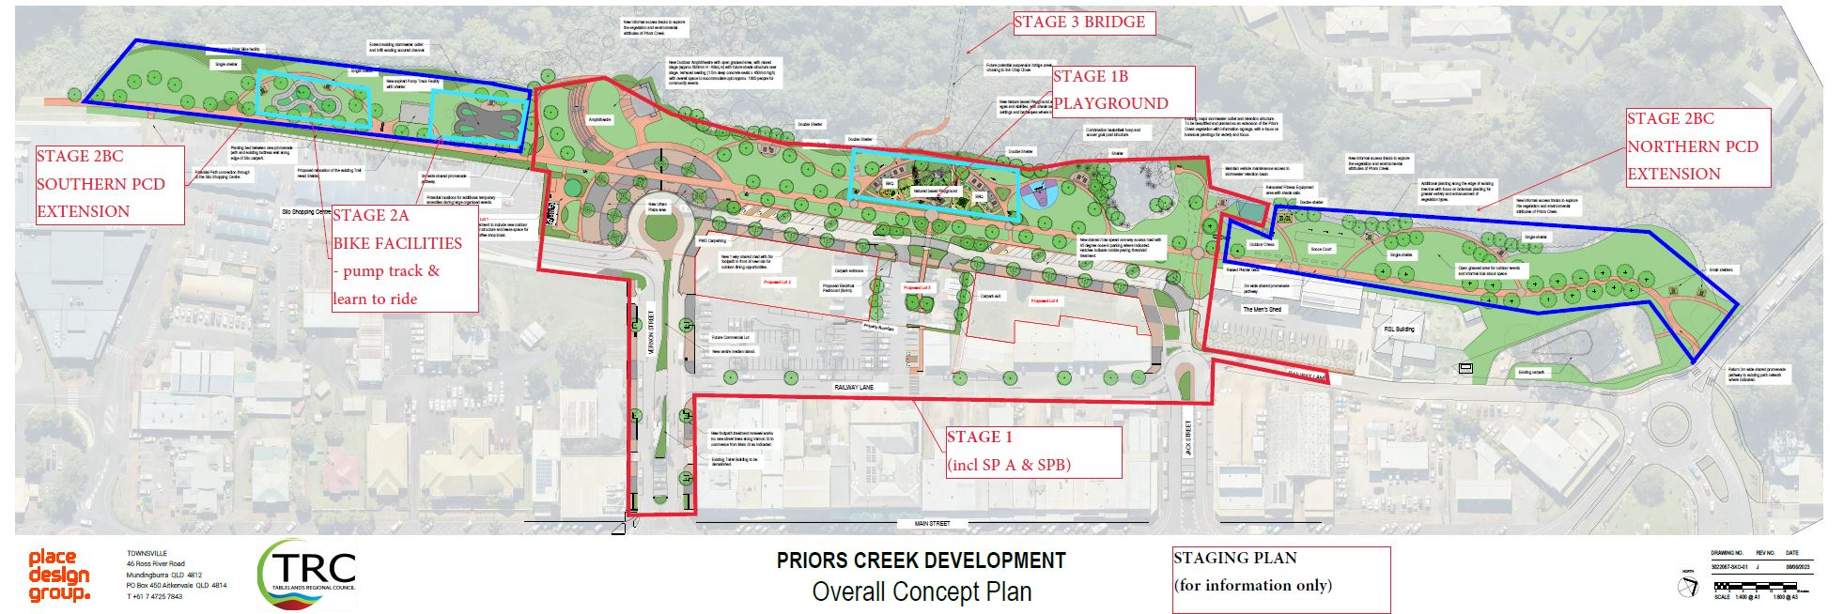
Figure 1- PCD Masterplan - Staging Plan

Ergon
Ergon will be undertaking the following electrical works as part of the project;
- Undergrounding the high voltage power that runs through the Site
- Roadway and subdivision works (electrical, streetlights, substations, RMU,etc)

Ergon’s works / timeframes are subject to Council’s Principal Contractor (this tender) installing the required Civil works (conduits, plinths, etc) as outlined in the above table and within Ergon Drawings (General Specifications).

Other Considerations

The Principal Contractor shall ensure tender pricing and methodology considers all site-specific matters including (but not limited to);

- Staging of the Works e.g. Separable Portions A & B
- Working beside Priors Creek / wet season considerations
- Long lead items ( e.g. stormwater pipes)
- Site access / constraints
- Working in collaboration with Ergon and other public utility providers
- Pedestrian management e.g. managing rail trail users during construction
- Providing site access to Council’s Contractors which could include (but not limited to) – Artwork installations, playground contractor, Ergon, NBN, etc.
- Appreciation of site ground conditions - Lot 155 SP120085 Priors Creek recreation corridor is on the Environmental Management Register (EMR) ( being a former rail corridor). Refer contaminated land assessments attached ( WSP report dated 24 May 23).

Timeframe
Council is working towards the following timeframes.
Procurement Activity | Timeframe
Tender Open | Refer below Part 2
Tender Close | Refer below Part 2
Tender Evaluation & TRC Decision (Council Meeting) | November 23
Contract Execution | November / December 23
Commence on Site - Separable Portion A | Late 23 / Early 24
Commence Separable Portion B (subject to funding / council direction – if ordered | Anticipated - April/May 24

PART 2 – GENERAL INFORMATION
- Contract details: | Priors Creek Development - Contract T-TRC2023-12
- Communications by Tenderers: | Communications regarding the Procurement Process must be submitted https://portal.tenderlink.com/trc no later than 7 calendar days prior to the time stated in Item 4
- Briefing or site inspection: | Details | Maximum attendees | Mandatory | RSVP
 | Optional Site Inspection  29/9/23 11:00am | NA | ☐ Yes  ☒ No | RSVP to procurement@trc.qld.gov.au
- Submission of Tender | Tenders must be submitted at https://portal.tenderlink.com/trc by no later than 4:00pm on 16 October 2023  Note// Adequate time must be allowed for the Tender and all supporting documents to be uploaded or received by this time.
- Evaluation Criteria | Evaluation Criteria |  |  |  | Weighting (%)
 | Price  Note//– Pricing and will consider Local Business Preference as described in the TRC Procurement Policy 2021/2022 |  |  |  | Cost Effectiveness Ratio
 | Non-Price Criteria
 | Relevant experience |  |  |  | 30%
 | Key personnel and skills |  |  |  | 30%
 | Resources and management systems |  |  |  | 10%
 | Understanding and methodology |  |  |  | 20%
 | Local Content |  |  |  | 10%
- Tenders should not be longer than: | No limit
- Tenders to be valid for: | 90 calendar days after the time stated in Item 4 (as extended if at all, pursuant to the Procurement Process Conditions)
- Complaints: | Complaints regarding Procurement Process to be directed to: procurement@trc.qld.gov.au
PART 3 – PROCUREMENT PROCESS CONDITIONS
The Procurement Process is governed by, and this Request for Tender is to be read in conjunction with, the Procurement Process Conditions:

☒ available for viewing or download from https://www.trc.qld.gov.au/download/procurement-policy/ “Procurement Process Conditions”
PART 4 – CONTRACT
☒ The contract shall be substantially in the form attached with this request for tender and identified as Contract - Priors Creek Development Contract T-TRC2023-12

PART 5 – SCOPE
☒ The Scope is described in the document(s) attached to or provided with this request for tender and identified as General Specifiction - Priors Creek Development - Contract T-TRC2023-12

PART 6 – RESPONSE SCHEDULES
The Tender must be submitted in the form provided in the response schedules attached to or provided with this request for tender and identified as Response Schedules - Priors Creek Development - Contract T-TRC2023-12

